Authentic Travel and Tours, LLC presents:
Fiber Art in Ireland with Nicola Brown :The Art of Eco Printing
September 10-16, 2017
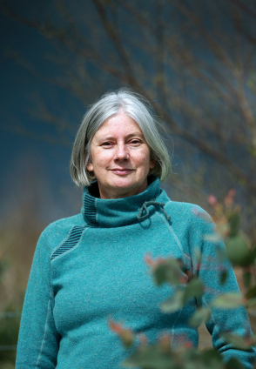
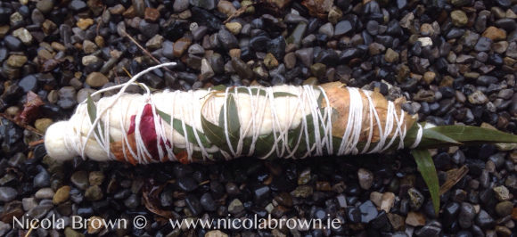
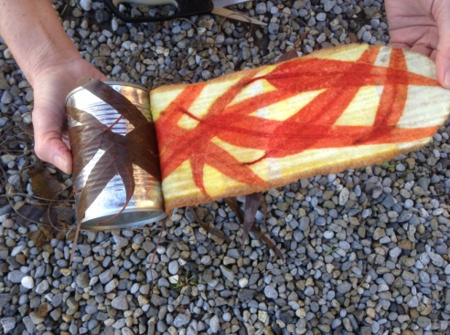
Join us for an Irish experience and art retreat with textile artist Nicola Brown in County Carlow, Ireland! An accomplished felt maker, Nicola has also researched and developed a beautiful line of “eco printed” textiles and clothing, using natural materials from the hedgerow, kitchen, gardens and woods surrounding her home. Once gathered, this vegetation is bundled in silk, wool or handmade felt and processed in well water to extract beautiful colour and prints. Participants will discover techniques, tips and processing methods, and can expect to create a variety of pieces during the week. This workshop is for anyone interested in learning the methods Nicola uses to achieve consistent and substantive prints on protein based fabric using a selection of local or easy to find natural vegetation (while enjoying the Irish countryside, food and culture!). These prints will be achieved in a simple and environmentally friendly way. Nicola is a renowned teacher, and has taught extensively on several continents. To learn more about her, and to see her at work, click on this video link: http://www.nicolabrown.ie/the-studio Learn more about Nicola, read her blog, and view her artwork at http://www.nicolabrown.ie Expect an amazing workshop!
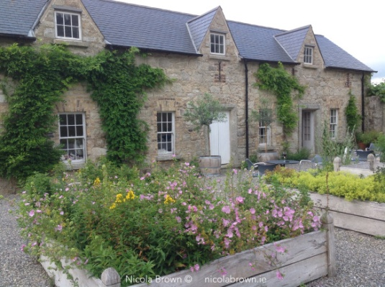
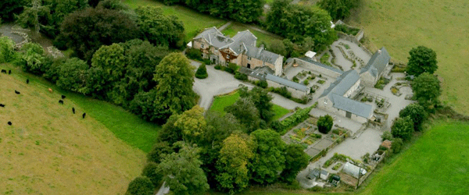
After arrival in Dublin, we’ll travel to Kilgraney House in County Carlow south of Dublin, (http://www.kilgraneyhouse.com), a luxurious manor house with marvelous gardens, which will be a botanical source for our projects. Consisting of a series of interconnecting herbal gardens, there is a large kitchen garden, a tea walk, a medicinal herb courtyard, a medieval monastic herb garden and a garden of aromatic and fragrant herbs. Read more about their marvelous gardens here: http://www.kilgraneyhouse.com/herbgardens.html
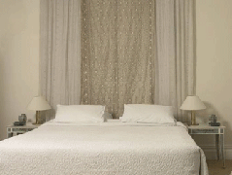
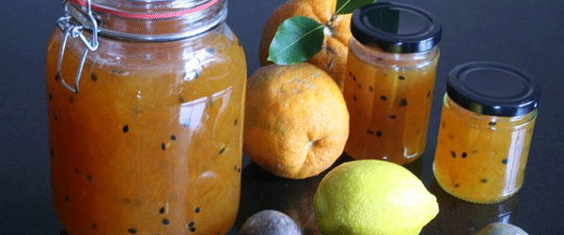
We will be lodging in guesthouses on the property, each with its own kitchen, sitting areas and private bathrooms. Bedrooms are shared with each person having a private bed. Each bedroom is named after flowers and herbs found growing at Kilgraney, and have signature teas and AromaSpa treatments for you to discover during your stay. Perfumed air from the herb gardens, birdsong in the surrounding trees and views from bedroom windows really immerse into the heart of the Irish countryside and help to reinforce your connection with nature. How perfect for learning eco-printing and making art! Comfortable beds and crisp cotton linens ensure you'll have a restful sleep in luxurious surroundings.
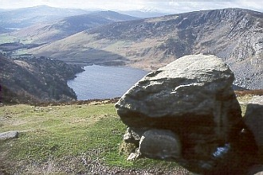
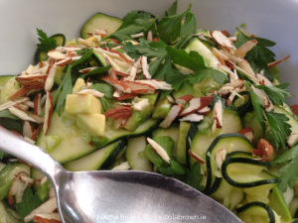
We will be treated to a delicious breakfast each day… the breakfasts at Kilgraney offer both traditional and healthy options, with freshly-squeezed orange juice, home-made breads, yoghurt, marmalades and jams. The honey is so local you can probably see the beehive from your breakfast table! All breakfasts are cooked to order. However, it’s Martin’s orange and raisin pancakes with crème fraîche that always receive much acclaim and remain a favorite item on the breakfast menu. Delicious lunches will also be provided, prepared with locally sourced, healthy ingredients. We will stop en route the first day so that you may purchase groceries for your evening meals, which you can prepare in your kitchen. You may also hire a taxi to visit a local restaurant or pub in the evenings if you choose.
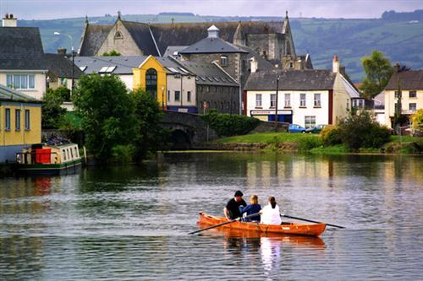
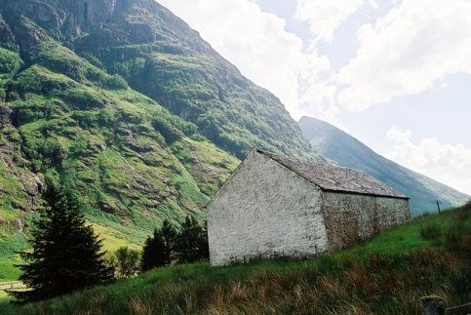
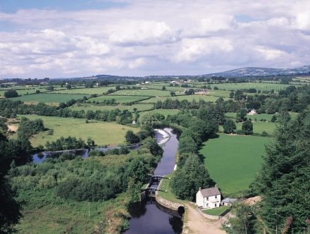
We hope to include some local outings during the week. This is “authentic” Ireland, far from the crowds, with quiet country roads, small villages, and green rolling hills. We will walk down the lanes, perhaps visit a local market, admire the sheep grazing, and get to know the land, people and place. Ireland has an ancient past, and we hope to visit some prehistoric sites in the area such as this dolmen from prehistory. Your tour leader will provide background and history of the region throughout the week.

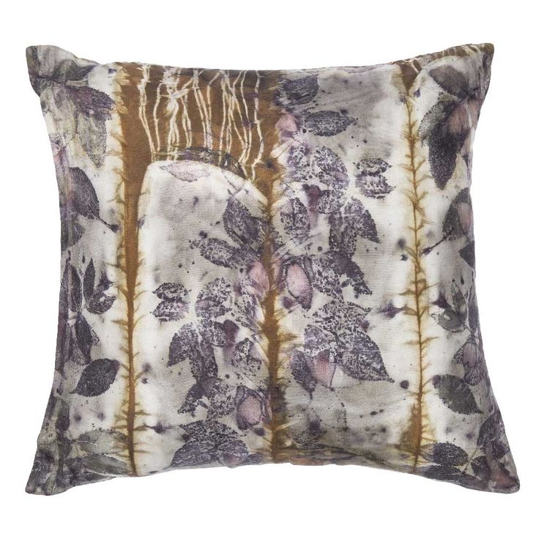
The Workshop
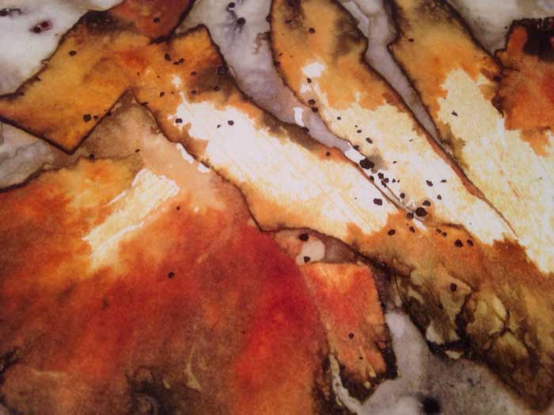
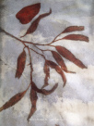
Our workshop with Nicola will begin with the creation of a felted piece on which we will later do some eco-printing. We’ll gather plants and create bundles using a variety of different materials and then dive into learning to use this process creatively. All of the materials will be provided, and participants can expect to create several projects. These are some of Nicola’s photos showing completed eco prints.

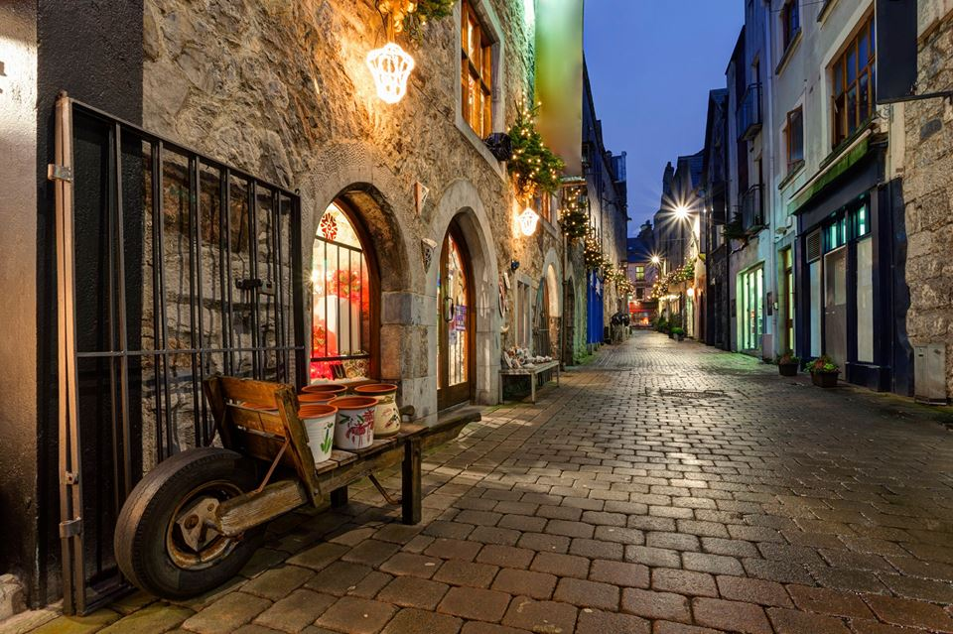
At the end of the week, we’ll have an exquisite gourmet farewell dinner prepared by our chef to celebrate our wonderful week of creativity and learning together. We’ll leave early the next morning and our bus will take participants to the Dublin airport by mid morning.
For those interested in spending a few days seeing some of the sights around Dublin and in the city, an “add-on” trip is available from September 16th-20th. Depending upon number of people interested a 4 day extension will be offered, which will include:
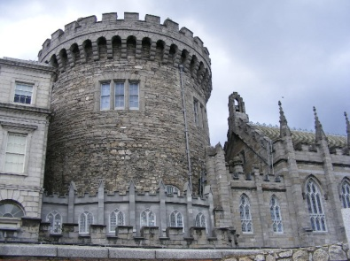
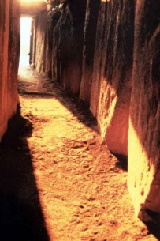
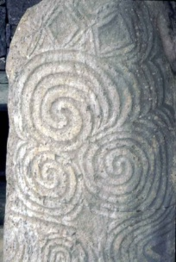
- A guided trip to Newgrange prehistoric site, http://www.worldheritageireland.ie/bru-na-boinne/built-heritage/newgrange a huge structure with inner chambers that capture the light on the winter solstice. This is a World Heritage site, well worth visiting! The rock art is amazing, and Joan will be sharing her own knowledge in addition to the Newgrange guide
- A walking tour of the city center, learning the fascinating story of Dublin’s history from the first people to the Vikings, as well as the current century and its history
- The Hop-on, hop-off bus, which allows one to visit many of the sites of interest without walking. A wonderful way to see the city too!
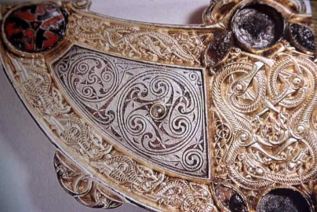
- Free time to visit other local attractions, such as the Book of Kells exhibit, Christchurch Cathedral, Dublin Castle, the National Gallery, and Dublin Writers’ Museum
- A guided tour of the National Museum, which has excellent exhibits on prehistory, the Celts, the Vikings, and monastic treasures
- Options to partake in the wonderful musical and literary pub tours in the evening. Other options include a folklore dinner, music and dancing. This add-on option is not included in the cost of the workshop trip, and final cost is dependent upon number of people and lodging costs. The estimated cost at this time is $685. If you are interested, please note on your registration form. More details will be sent upon registration.

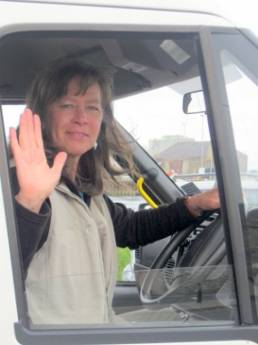
Your Tour leader and Guide: Joan Molloy Slack has been leading small group tours for many years, initially as a college instructor, and then through launching her business “Authentic Travel and Tours, LLC”. She will also serve as your leader throughout the tour. She is an artist, gallery owner and teacher, and has been organizing and leading tours for 16 years to Mexico, Ireland, Scotland, France and within the United States. She holds a Master’s Degree Visual Art, and will bring her knowledge of art history, experience as a museum curator, and passion for art past and present to our workshop activities and discussions. As an artist, she focuses on felt-making, sculpture and pottery. You can view her artwork at www.riverrunarts.com . As a firm believer in sustainable tourism, she also seeks out the best local guides, from historians to storytellers, so that we may hear and see through their eyes as well. She is a dual citizen, Irish/American, and her family comes from a small town called Rathcabbin in Tipperary. You can read about her travel adventures and research in Ireland at www.authentictravelandtours.com
“I began tour guiding 17 years ago through teaching college classes combined with tours in Art History to Mexico and Ireland. I also led independent travel experiences that included Ireland as well as Scotland and France, after researching prehistoric art and ceramics and attaining my Master’s Degree. My fascination with the people who were the first recorded artists, as seen in the cave paintings in France, or on ancient pottery designs or rock art carvings, continues to drive my desire to learn, explore and share my passion for what I have learned with fellow travelers. As an artist, teacher, art historian, scholar and adventurer, I am so looking forward to sharing amazing people, places and experiences with you!”
Registration is limited to 8 people! Register as soon as possible to assure a place. Spaces will be filled on a first-come, first-served basis. A waiting list will be developed in case of cancellations.
Trip Details, Terms and Conditions: The cost of the trip is per person, double occupancy, and is based upon current quotes from vendors and transportation providers. If the value of the dollar to the Euro changes significantly prices may have to be adjusted. Cost: The price of this workshop is $1795.00
What is included in the cost of the trip:
- Lodging for tour dates at Kilgraney House. Price is based upon 2 sharing a room with your own bed. Due to limitations at Kilgraney House, there are no options for single rooms.
- All ground transportation to and from our destination in Ireland after arrival and until last day of trip. Travel will be with licensed coaches and drivers
- A 5 ½ day hands-on workshop with Nicola Brown including feltmaking and eco-printing
- All class materials and supplies
- Finished individual projects to take home
- Full Irish breakfast made to order every day with tea and coffee
- Delicious gourmet lunch every day of the workshop, prepared by the chef
- A gourmet dinner at Kilgraney House on our final evening, including wine
- Customized demonstrations, presentations and guided instruction with Nicola Brown
- The personal attention of the tour leader
What is not included:
- Evening meals with the exception of the gala event Friday night
- Travel to and from Ireland and any travel outside of tour dates. The tour begins and ends at the Dublin airport where you will be picked up and dropped off by our driver.
- Insurance for health, luggage, transportation, cancellation/interruption. We strongly advise that you purchase travel insurance
- Any extra or “optional” sightseeing, tours, taxis, or tickets
- Food for preparing your evening meals, should you choose, at Kilgraney House. There are grocery stores within 3 kilometers, and several options nearby for take-away and dining out, but a taxi would need to be arranged. We will make a stop for provisions for the week upon arrival.

Registration and Payment Information: To register for the tour, please send a check for $1795.00 and the completed registration form below. We need to provide payment to our providers several months in advance, which is why we request the full trip amount. You may also pay by credit card for a 2.5% administration fee: call to pay by this method. You must also complete the form at the end of this brochure and mail with your payment to be registered in the workshop. Space is very limited and registrations are on a first-come, first -served basis. Please e-mail at joanslack33@gmail.com or call Joan Slack at 715-277-2773 (work) or 715-550-0858 (cell) with any questions. (Please note: Joan will be travelling overseas and making tour arrangements, and is best reached by e-mail or text message to her cell phone March 2nd- April 11th.)
Follow-up confirmation and information will be mailed to you upon registration, along with more tour details and travel tips, what to bring, reading suggestions, information on eco-prinintg, and flight booking details. Please do not book a flight until you receive confirmation in writing that the trip is full. We suggest that you consider arriving in Ireland a day early to adjust to the new time zone. We can suggest lodging. This is also helpful if there are flight delays.
Cancellation policies: Cancellation fees apply regardless of the reason. We strongly recommend travel insurance that includes trip cancellation coverage to protect against financial loss due to cancellations or trip interruptions. All cancellations must be in writing, and received before the deadlines listed below. The following penalties and refund policies may apply:
$100 charge plus any unrecoverable deposits or payments to hotels, sites, tour operators or transportation providers, March 10-through May 1, 2017.
From May 1-June 30, 2017, 50% of tour price and any unrecoverable deposits and payments.
After June 30, 2017, no refund will be allowed.
The tour cost is per person based on currency valuations as of February, 2017. We will do everything possible to maintain costs, tour terms and itinerary, but they are subject to change due to circumstances beyond our control or large fluctuations in currency values. If the accommodation and other provided services need to be changed for reasons beyond our control, we will make every effort to find lodging and services of equal quality.
We reserve the right to cancel the tour prior to departure

For more Information on your tour leader: www.authentictravelandtours.com (see blog), www.joanslack.com, www.riverrunarts.com
Some scenes from Ireland and County Carlow…….
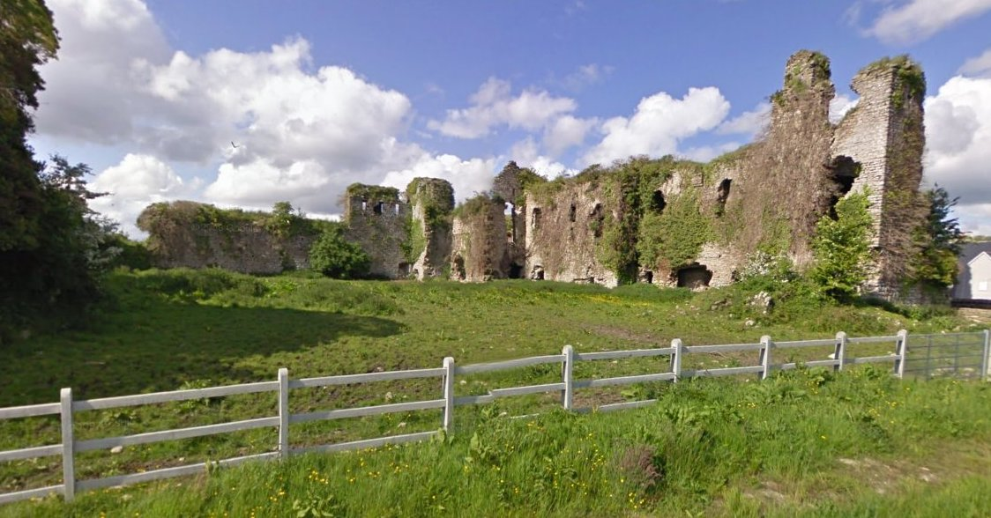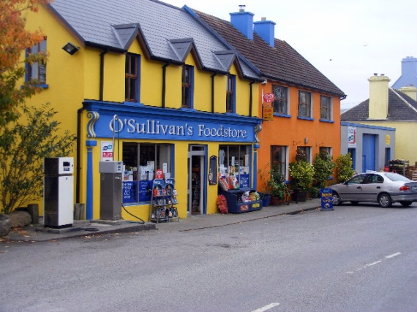
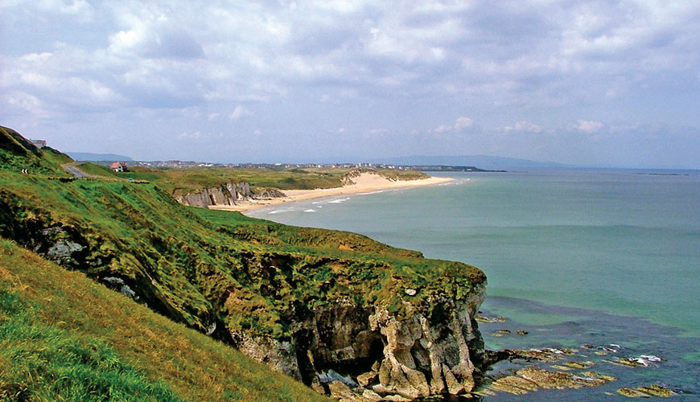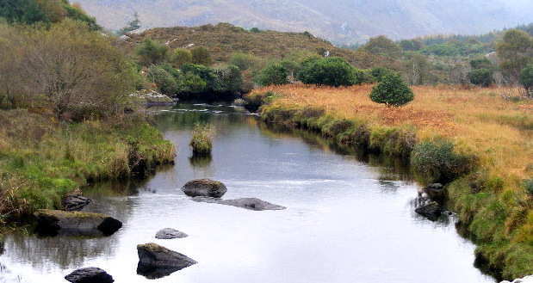

To register please return the following information with your payment of $1795.00: Make check payable to Authentic Travel and Tours, LLC Mail to: Joan Slack, P.O. Box 95, McNaughton, WI 54543

Name:____________________________________ Email:__________________________________

Address:__________________________________________________________________________
Birthdate:____________________

Home phone #:____________________________Cell phone #:____________________

Roommate preference:____________________
Emergency contact: Name, relationship, phone, e-mail address:

Are you interested in registering for the “add-on” trip? ___________ (Specific details, costs and itinerary will be sent: do not send payment now)

Use the back side of this form to list any food preferences (vegetarian, etc) or other health issues we should know about. Also, please list prescription medications or health conditions for which a doctor should be aware in case of an emergency.

WAIVER OF RESPONSIBILITY
Authentic Travel and Tours, LLC, and The Tour Leader (hereafter referred to as “TL”), Joan Slack, gives notice that all arrangements made by her as agent upon the express conditions that she shall not be responsible for any damage, injury, loss, accident, delay or irregularity which may be occasioned either by reason of any defect of vehicle, or through the acts of default of any company or person engaged in conveying the passenger, or in carrying out the arrangements of the tour, or otherwise in connection therewith, nor does she accept responsibility for losses or additional expenses due to delays or other changes in means of transportation or other services, due to sickness, weather, strikes, or other causes. The right is reserved to make such alterations, deletions, additions, or modifications in the itinerary, program, or accommodations as may be found necessary by the TL. While every effort is made to assure safety, the TL, and agents of the TL will not be acting in a supervisory capacity during the tour and accordingly do not accept responsibility for the activities or safety of participants. In addition, TL shall bear no responsibility for medical or other expenses resulting from illness, injury, or accident which occurs on the tour. Participants are encouraged to be adequately insured, both for health and travel. Participants understand that there is an assumed risk to overseas travel. No illegal drugs or firearms are permitted. Participants are expected not to deviate from the established itinerary without prior approval from TL. If for any reason a participant must leave the tour before completion, no refunds will be allowed. TL reserves the right to ask a participant to leave the tour due to behavior that may endanger the safety of the group.
My signature certifies that I have read the “Waiver of Responsibility” and that I agree to the conditions thereof.

______________________________ ___________________
Signature Date

