Authentic Travel and Tours presents
Ireland and the Wild Atlantic Way
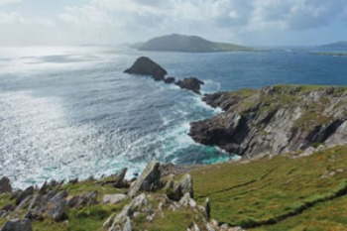
October 8-15, 2015
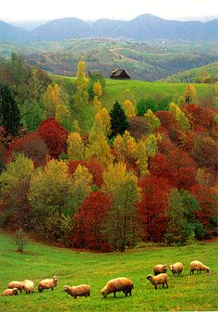
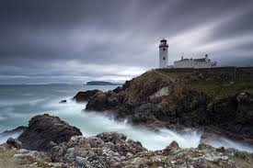
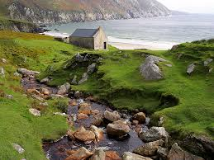
Join us for a trip along the Wild Atlantic Way, which stretches for 1,500 miles along Ireland’s western seaboard. This trip will be focused on the southwestern part of the “way” where we will explore the history, culture, archaeology and secret places of this coastline. Kerry tourism states “Here, the ocean’s force has carved a coast of wild, raw beauty. Huge Atlantic rollers crash and churn, shaping jagged ocean crags, archipelagos and inlets, sea loughs, surfing strands, and the sheer granite walls of cliffs that are amongst some of the highest in Europe. Rare sea eagles circle over glacial mountains, dolphins leap the waves, seals bask on the shore, puffins nest on cliff faces and geese gather in great estuaries. And lighthouses safeguard sailors all the way up the coast “. It is with this splendor as our constant companion that we will explore, delve into the ancient past, and experience Ireland in a way you will always remember. An added attraction of this tour will be the opportunity to bring your sketchbook and paints for quick studies in the landscape with artist Dennis Robertson, who invites those interested to join him in capturing some of the beauty we will witness. We will be encouraging time for photography as well, taking ample time and opportunity to capture picturesque places in photos.

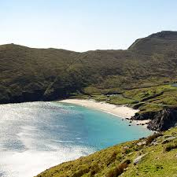
The trip will begin in Dublin, where we will learn about the culture and history with a walking tour and visits to several places of interest, such as the National Museum and Dublin Castle. Next we will travel to the Beara Peninsula. We will stay for several nights as we explore the coast, standing stones and circles, and legends in the landscape, such as the “Hag of Beara”. We will visit contemporary artists in their studios, see top notch art galleries, and attend a special performance by a local storyteller, or “seanachie”, Teddy Black. Tiny roads hug the shoreline, and the ocean turns hues of azure, grey, and cobalt blue as the weather changes throughout the day. The people we will meet will remain your best memories, and in many places called the “Gaeltacht,”, Irish is still the spoken language. You may often hear “Fáilte romhat isteach” meaning “You’re most welcome here”.

Along the way, stops at waterfalls, scenic areas and winding forest paths to take short hikes will enable us to photograph, sketch and absorb the spectacular beauty of the region, from mountains to green fields and seascapes.

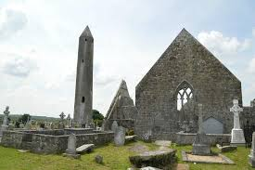
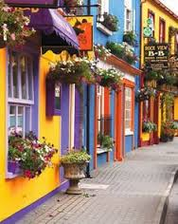
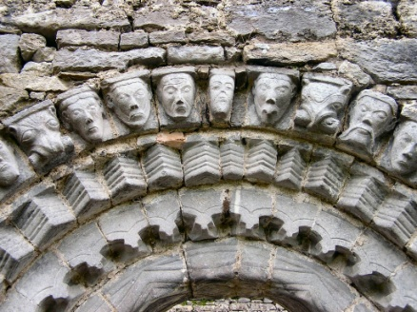
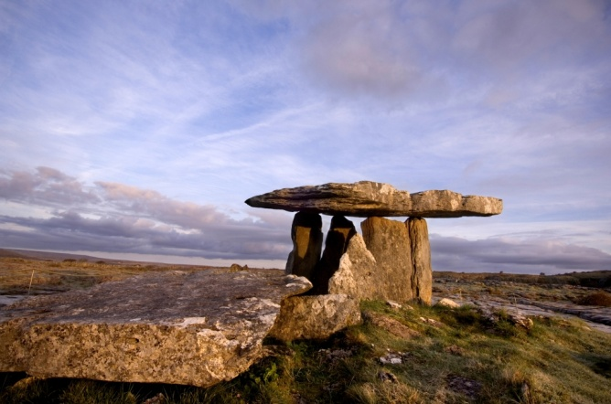
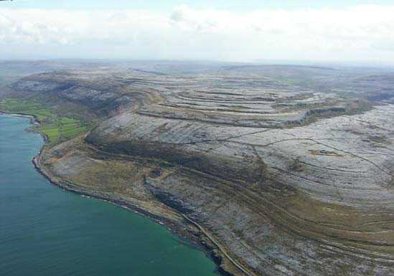
We then head to the Burren, further north on the Wild Atlantic way, watching for dolphins, eagles, and great beaches to walk and explore. Here we will enjoy the unique Burren landscape of limestone, visit ancient dolmens, and walk with a local guide to “off the beaten track”, magical places, such as holy wells and prehistoric cairns. A highlight of our time here will be a day with award winning guide and author Tony Kirby. The Burren National Park is an area of outstanding natural beauty. Some of the highlights of the Park include the dramatically-buckled Mullaghmore hill, turloughs (seasonal lakes), great expanses of limestone pavement and stunning "wallscapes" (dry stone walls). Herds of feral goats are frequently spotted. The Park hosts the Burren’s renowned mix of wildflowers from the Alps, the Mediterranean and the Arctic. Our walk features nineteenth century potato cultivation ridges, a Great Famine relief road from the 1840s, a Stone Age megalithic tomb and impressive views of parts of Counties Clare and Galway. The outing includes incisive commentaries on the geology, archaeology, history, flora, wildlife and farming of the Burren.

All throughout our trip we will sample fresh seafood, hear local musicians, drive through brightly painted villages, and walk among monastic ruins and round towers. We’ll return to enjoy one last day in Dublin. We are also offering a tour that begins and ends in Dublin October 20-31, which you are welcome to join if you would like to extend your travels in Ireland! ( details at www.authenticravelandtours.com or www.riverrunarts.com)

Itinerary

10/8 Arrive Dublin. Walking tour and visit to National Museum. Optional musical pub tour in evening

10/9 Travel to the southwest to the Beara peninsula. Stop at Gleninchquin Waterfall and other sites of interest for short hikes and scenic views. Lodging in a small village in Beara

10/10 Day trip around the coast of Beara, with stops at stone circles, artist’s studios and galleries, Allihies copper museum. Dinner in Castletownbere and evening performance by storyteller Teddy Black

10/11 Day trip including Healy Pass, the Hag of Beara, standing stone, local artisans

10/12 Travel to the Burren along the coast. Ring of Kerry sites, such as Eightercua stone alignment, Staigue Iron Age Fort, and monastic sites Dysert O”dea and Kilmacduagh. Lodging in the Burren.

10/13 Walking tour with local guide Tony Kirby in Burren, visits to many area attractions

10/14 Return to Dublin, visit points of interest. Farewell dinner

10/15 Depart
Please note: This tour will involve some moderate hiking and walking on uneven terrain.

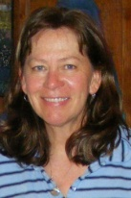
Your tour leader and guide: Your tour will be led by scholar, artist and teacher Joan Molloy Slack, who will guide the tour and interpret the range of fascinating things we will see and experience, from rock art to Irish culture and contemporary art. She has been organizing and leading tours for 15 years to Ireland, Scotland, France, and Mexico as well as within the United States. She is a teacher and college instructor, a ceramic and fiber artist, (www.riverrunarts.com), and holds a Master’s Degree in Prehistoric Ceramics and Visual Art. Joan will bring her knowledge of art history, experience as a museum curator, and her passion for art and history to our daily excursions. As a firm believer in sustainable tourism, she also seeks out the best local guides, from historians to storytellers, so that we may hear and see through their eyes as well. She is a dual citizen, Irish/American, and her family comes from a small town called Rathcabbin in Tipperary. You can read about her travels and research in Ireland at www.authentictravelandtours.com

“I began tour guiding 15 years ago through teaching college classes combined with tours in Art History to Mexico and Ireland. I also led independent travel experiences that included Ireland as well as Scotland and France, after researching prehistoric art and ceramics and attaining my Master’s Degree. My fascination with the people who were the first recorded artists, as seen in the cave paintings in France, or on ancient pottery designs or rock art carvings, continues to drive my desire to learn, explore and share my passion for what I have learned with fellow travelers. As I researched and traveled, I found that the best way to delve deeply was to seek out local guides, artists and historians who helped bring the stories of places alive. This never fails to create a rich, meaningful and life changing experience. Layers of story, place names, deeper meanings and human connection create a rich, multi-layered tour with memories that remain long after the travel is over. I bring this element to all of my tours, and it makes all the difference in what feels authentic versus an overview, or a superficial tour. As an artist, teacher, art historian, scholar and adventurer, I am so looking forward to sharing amazing people, places and experiences with you!”

Comments from past tour participants:
"My travel experience with Joan leading the group was above and beyond my expectation. Joan's research into so many areas of interest about the sites and folklore made the trip stimulating and insightful without being overloaded. She is a seasoned guide with great “in country” connections and a sincere love of the land she travels. I highly recommend Joan Slack as a tour guide. You will have a wonderful, memorable time. I did." J.H.
“Joan organizes her trips like she creates her art: beautiful, practical, and full of meaning. I'd never been on a group trip before. Joan's voyage to Orkney in Scotland was a joy, every day. It's one of the very best adventures of my life.” C. P.
“If you want dependability combined with unique experiences, attention to details and wonderful connections, this is a great tour to take. Each day has been planned for a balance of activities, a good pace and plenty of enjoyment. Joan’s background and knowledge really makes for a deeper understanding of everything we see.” K.M.W.
“If you have never been on a small group tour, go with Joan. If you have been with someone else, go again with Joan. Her planning, arrangements, and site selections are perfect! You will meet warm, friendly and local people from all walks of life with talents to share. I still have a Bridget’s Cross, made by Joe from our trip, hanging by my door. Happy travels!” A.H.
Our Vision: Each of our tours is unique and custom-designed, with a balanced mix of traveling, sightseeing, cultural encounters, and free time. We limit our tours to fewer than 20 people both for the freedom, flexibility, and camaraderie that small groups engender, and also so that guests may enjoy a more personal and authentic travel experience. We’ll show you the highlights and the unexpected. We usually spend more time in one place so that you won’t be constantly moving, and have time to get to know it. As small group your Tour Leader will have more time to spend with you and more time to share the personal insights that can add so much to your experience. This helps make your trip genuinely special and different from conventional tours, large buses, and too little time in one place.
Cost: The cost for this tour is $1675 per person. (Additional cost for single room)

What is included in the price:
-Lodging for tour dates at centrally located hotel and guesthouses.Price is based upon 2 sharing a room with your own bed if preferred. 3 people can share a room with 3 beds if available. There is an additional charge for single room- please contact us about the extra cost. Single rooms may have limited availability and are on a first-come, first served basis.
-All ground transportation, including buses, taxis, train and coaches in Ireland after arrival at hotel and until last day of trip
-Full Irish breakfast every day with tea and coffee
-All tour guides and admission fees, walking tours, and special events in itinerary
-guided presentations at site visits, and gratuities
-customized special events, tours, presentations and/or performances

Price does not include:
-lunches and evening meals (we have opted not to make meals all-inclusive due to personal preferences and dietary issues. This also gives people the freedom to explore and sample a variety of restaurants and cafes)
-travel to and from Ireland and any travel outside of tour dates. The tour begins and ends at the Dublin hotel: transportation by bus or taxi to/ from airport is not included
-insurance for health, luggage, transportation, cancellation/interruption. We strongly advise that you purchase travel insurance
-any extra or “optional” sightseeing, tours, taxis, or tickets, such as the evening pub tours

Please contact us at 715-277-4224 or 715-550-0858 with any questions or e-mail joanslack@wildblue.net.
If you are interested in joining us on the tour, fill out the attached forms and mail with your deposit of $500 (payable by check) as soon as possible to Joan Slack, P.O. Box 95, McNaughton, WI 54543. Space is limited, and registrations on a first come-first served basis. There will be a waiting list once the trip is full. Balance ($1175) is due August 1, 2015. A detailed itinerary will be mailed to you, along with travel tips, what to bring, reading suggestions, and information about sites that we will visit, closer to the tour dates.
Refund Policy
All cancellations must be in writing, and received before the deadlines listed below. The following penalties may apply: Up to $100 charge plus any unrecoverable deposits, any unrecoverable payments to hotels, tour operators or transportation providers, up to August 1, 2015. After August 1, 2015 – no refund will be allowed. The tour cost is per person based on currency valuations as of January, 2015. We will do everything possible to maintain costs and itinerary, but they are subject to change due to circumstances beyond our control or large fluctuations in currency values. The itinerary may be adjusted due to weather or provider conditions at our discretion.

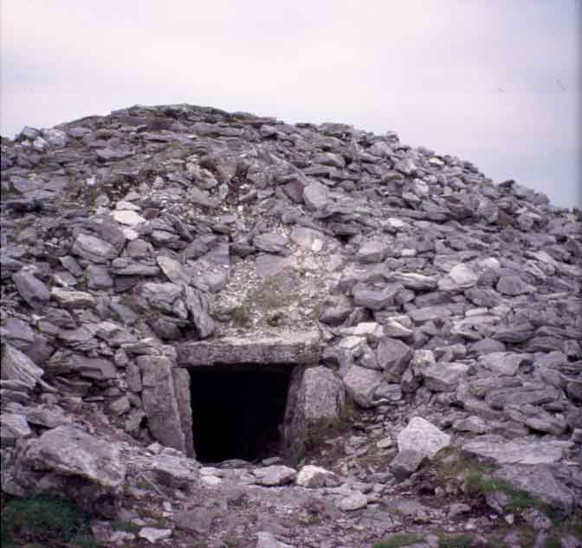
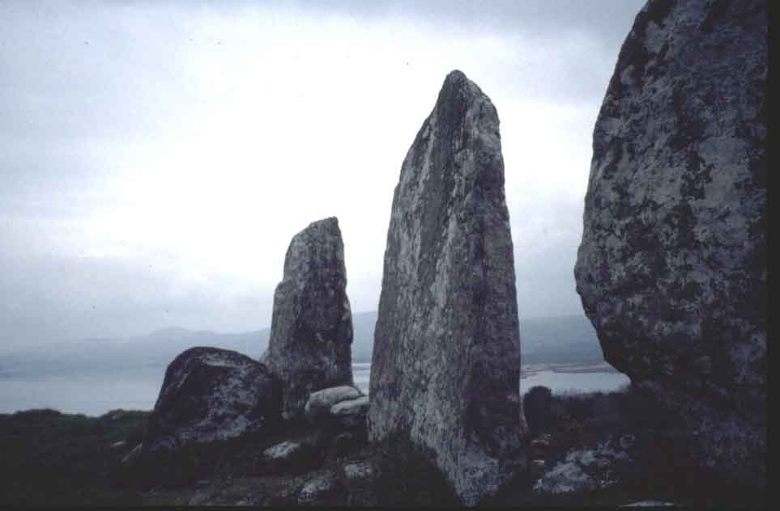
From ancient stone cairns and stone alignments, monastic ruins and echoes of the past in the landscape, to spectacular beauty along the Wild Atlantic Way, let us help you experience authentic Ireland on a trip you will always remember!

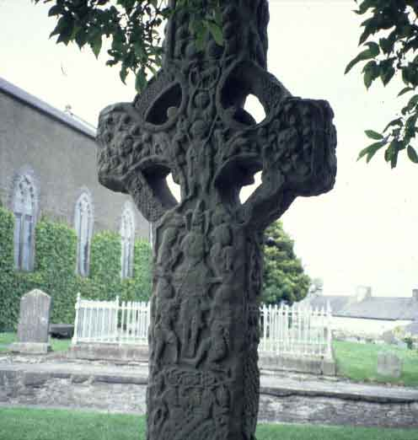
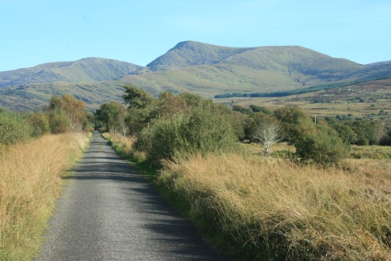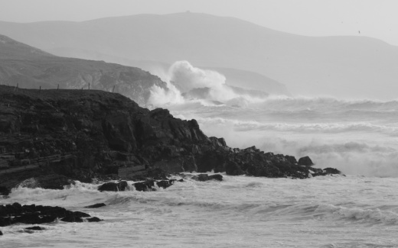

To register please fill out the following information: Tour dates: ____________________

Name:______________________________________________Birthdate:_____________

Address:____________________________ E-mail address:_____________________

_____________________________________________
Home Telephone #:_____________________Cell phone#:__________________________
Room preference: Single Double Triple Roommate(s) preference:____________________
Emergency contact: Name, relationship, phone, e-mail address:

Please list any food allergies or other health concerns. Also, please list prescription medications you are using in case of an emergency. (Please use a separate sheet of paper)

WAIVER OF RESPONSIBILITY
The Tour Leader (hereafter referred to as “TL”), Joan Slack, gives notice that all
arrangements made by her as agent upon the express conditions that she shall not be responsible for any damage, injury, loss, accident, delay or irregularity which may be occasioned either by reason of any defect of vehicle, or through the acts of default of any company or person engaged in conveying the passenger, or in carrying out the arrangements of the tour, or otherwise in connection therewith, nor does she accept responsibility for losses or additional expenses due to delays or other changes in means of transportation or other services, due to sickness, weather, strikes, or other causes. The right is reserved to make such alterations, deletions, additions, or modifications in the itinerary, program, or accommodations as may be found necessary by the TL. While every effort is made to assure safety, the TL, and agents of the TL will not be acting in a supervisory capacity during the tour and accordingly do not accept responsibility for the activities or safety of participants. In addition, TL shall bear no responsibility for medical or other expenses resulting from illness, injury, or accident which occurs on the tour. Participants are encouraged to be adequately insured, both for health and travel. No illegal drugs or firearms are permitted. Participants are expected not to deviate from the established itinerary without prior approval from TL. If for any reason a participant must leave the tour before completion, no refunds will be allowed. TL reserves the right to ask a participant to leave the tour due to behavior that may endanger the safety of the group.
My signature certifies that I have read the “Waiver of Responsibility” and that I agree to the
conditions thereof.

______________________________ ___________________
Name Date

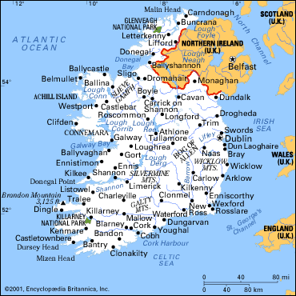
For more information and taste of the tour:
Beara peninsula http://www.bearatourism.com/archaelogical.html
The Burren http://www.burrennationalpark.ie/
National Museum of Ireland www.museum.ie
National Gallery of Ireland http://www.nationalgallery.ie/
Kilmainham Jail http://en.wikipedia.org/wiki/Kilmainham_Gaol
Trinity College and The Book of Kells exhibit http://www.tcd.ie/Library/bookofkells/
Newgrange, prehistoric World Heritage Site http://www.worldheritageireland.ie/bru-na-boinne/built-heritage/newgrange/
Dublin Literary Pub Crawl http://www.dublinpubcrawl.com/index.htm
Traditional Irish Music Pub Crawl http://www.lonelyplanet.com/ireland/dublin/activities/history-culture/dublin-traditional-irish-music-pub-crawl
Over the Top Tours See the Celtic Experience tour http://www.overthetoptours.com/
Liddy Historical Walking Tours, Dublin http://www.walkingtours.ie/

Some of the spectacular scenery we will see on this trip! We hope you will join us!!
